**Project Proposal**

**On**

**Online Laundry**

**Computing Project**

**Softwarica College of IT & E-Commerce**

**April 9, 2019**

**Submitted to: Submitted to:**

**Niman Maharjan Nixon Dangol**

**Computing Project 00175031**

**Module Teacher Batch 22 D**

Contents

Overview 4

1. Introduction 4

2. Justification 4

3. Description of the project 4

4. Scope 5

a. Aim 5

b. Objectives 5

5. Development method 6

6. Project planning 8

a. Work breakdown system (WBS) 8

b. Time estimation 9

c. Milestones 10

d. Schedule 10

7. Other project activities 13

a. Risk management 13

b. Configuration management 14

Conclusion 15

Figure 1: Waterfall Model 5

Figure 2: WBS Structure 7

Figure 3: Scheduling 1 10

Figure 4: Scheduling 2 11

Figure 5: Configuration Management 13

# Overview

## Introduction

In recent times appearance has become a vital part in every person’s life, providing laundry service to the people in need can prove to be an effective way of doing business. These laundry services can be made accessible to the public with the help of a user-friendly application.

## Justification

I have planned this project because, with this software I will be able to assist the people who are running small business. We can see that many of people and students are unable to get their laundry on time due to their busy hours along with-it small business are not able to do it due to economic issue. So, in order to benefit these entrepreneurs, I will be developing this project. It is very easy to use and user friendly

## Description of the project

The Laundry Management System is designed for any Laundry firm to replace their existing manual, paper-based system. The new system is in form of an e-registration system to control the following; customer information, products, services, users, carts and receipt. These services are to be provided in an efficient, cost effective manner, with the goal of reducing the delay and resources currently required for such tasks as clothes details are bounded to a particular customer with a given id. Since the existing system makes use of tedious administrative tasks, lots paper work and time, in which full information cannot be gotten from busy customer

s.

This programming is based in PHP and other languages which will make it a web-based application. People will be allowed to place order online and the clothes will be picked up from their pickup location. The rate will also be included in the webpage. It will be a multiuser application in which will be two types of user and they are normal user which are termed as clients and admin which are termed as the owners of the shop or those who have modify the data in the webpage.

The features of the application that I am going to develop in the near future are listed below

1. Login
2. Registration
3. Password change
4. Placing orders

a. Laundry Rate Card

b. Add clothes

c. Order Confirmation

1. Multiple users
2. Online payment

## Scope

The application will be available to those who wants to implement modern approach of registration for online laundry by helping them to manage time replacing the old paper registration system. It must be acquired from the developers and will be economical and reliable to those who wants to use this software (Anon., 2019).

### Aim

With the following aims I am going to complete this project

1. Develop web-based application for small business for online laundry.
2. Develop a software with possible maximum features with minimum cost.

### Objectives

The main objective of building an application on laundry services are

1. Managing time to working class people
2. Connecting customers and dhobis.
3. To promote the small business.

## Development method

It is a main process of developing a software. There are many approaches for the development of the software. Development method is chosen by the demand of the software which is going to be developed. Some of the development methods examples are SSADM, DSDM, Agile, Object Oriented, etc.

For this project, I am going to choose Waterfall Model because it is one of the easiest ways of developing method. In this method, the project is divided into several parts which are completed step by step. We cannot go back to the completed steps (EPA, n.d.).

The steps which are included in the waterfall model are listed below:

* Requirement Analysis
* System Design
* Implementation
* Testing
* Deployment
* Maintenance

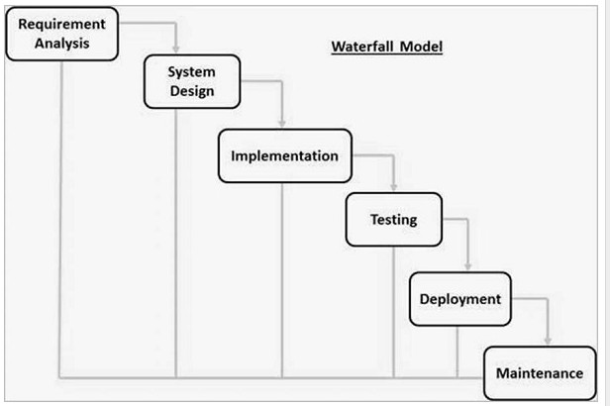

Figure 1: Waterfall Model

I have chosen waterfall method due to following reasons

1. Due to inflexibility, it is easy to manage.
2. It is simple and very easy to understand.
3. As it is a smaller project it is very effective for this project
4. The steps are not overlapped.

I am not picking other development strategy since I won't possess significant lot of time for the improvement of the project. It is a small project which must be created in a brief time of a period. On the off chance that I pick, another improvement strategy as opposed to waterfall model than I may return to the progression of steps and hence problem of trapped may arise. This will influence in the planning and I won't probably complete the project on schedule. Along these lines, because of this reason I have not picked other development strategy.

## Project planning

### Work breakdown system (WBS)

It is a chart which in which the critical work elements called tasks or steps are illustrates to portray their relationships to each other and to project as a whole. The breaking of the project helps to reduces complexity and makes easier to understand the project.

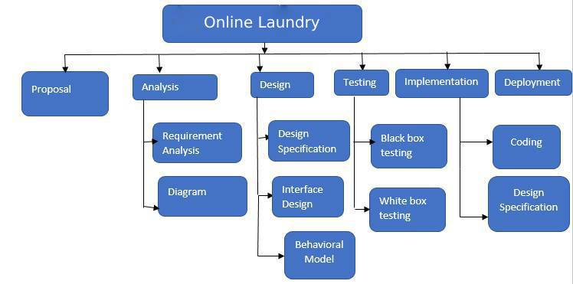

Figure 2: WBS Structure

The above figure shows the work breakdown of the task I have picked which shows the project being partitioned in the few sections. In the underlying phase of the task, I have done the proposition through which the task should be possible. After the proposition I will do the examination project which will assist me with completing the task. The examination will assist me with knowing what highlights to incorporate and what not to. In the investigation part, there are two sub gatherings and they are Requirement examination and graph. In the prerequisite investigation the necessities for the project are divided. Essentially, in the outline part extraordinary graphs identified with the undertaking are drawn, for example, class diagram, activity diagram, use case diagram and so on if possible. After the investigation, the plan part will be finished. In this part the structure of the picked application is made. The plan will as easy to use as it can. Something else, the client will feel exhausted and won't favor the application. With this I will do coding and the structure determination in the execution part. This is where I will build up the application. After this I will do the testing part on the grounds that there might be minor bugs which I may have done in the coding time. I will do Blackbox and white box testing. This will let realize that the application that I have created is working appropriately or not. Furthermore, toward the finish of the work breakdown, I will do the documentation part. This part will assist other individuals with understanding about the application. They will have a tad of look at the application through the documentation.

### Time estimation

Time is a key note for the completion of this task. Everything ought to be done inside the time. Otherwise, the task will be failed and I may not have the capacity to complete the project in the given time. In this way, I distributed the associated time estimation for the project.

|  |  |  |
| --- | --- | --- |
| **WBS** | **Task name** | **Days** |
| **1** | **Proposal** | **16 days** |
| 1.1 | Planning | 6 days |
| **2** | **Analysis** | **15 days** |
| 2.1 | Requirement Analysis | 10 days |
| 2.2 | Diagram | 5 days |
| **3** | **Design** | **30 days** |
| 3.1 | DesignSpecification | 10 days |
| 3.2 | Interface Design | 15 days |
| 3.3 | Behavioral Design | 5 days |
| **4** | **Implementation** | **32 days** |
| 4.1 | Coding | 27 days |
| 4.2 | Design Specification | 5 days |
| **5** | **Testing** | **15 days** |
| 5.1 | Blackbox testing | 5 days |
| 5.2 | White box testing | 10 days |
| **6** | **Documentation** | **20 days** |
|  | **Total** | **128 days** |
|  |  |  |

### Milestones

I have thought some about the dates in which I will do the individual pieces of the project. This is known as milestone. I will total the milestone so as to finish the project in time. The accompanying table is the sign of the achievements I will accomplish so as to completing the undertaking in time

|  |  |  |
| --- | --- | --- |
| **S. N** | **Milestone** | **Date** |
| 1 | Proposal | 9 April, 2019 |
| 2 | Analysis | 24 April, 2019 |
| 3 | Design | 24 May, 2019 |
| 4 | Implementation | 25 June, 2019 |
| 5 | Testing | 10 July, 2019 |
| 6 | Documentation | 30 July, 2019 |

### Schedule

The steps are done well ordered. Here, I will pick the Waterfall model thus, I won't probably return back to the finished project yet I will be just pushing forward. In this way, I have evaluated days for the finishing of the project. The following is table demonstrating the calendar for the finish of the task

|  |  |  |
| --- | --- | --- |
| **S. N** | **Parts** | **Days** |
| 1 | Proposal | 16 days |
| 2 | Analysis | 15 days |
| 3 | Design | 30 days |
| 4 | Implementation | 32 days |
| 5 | Testing | 15 days |
| 6 | Documentation | 20 days |

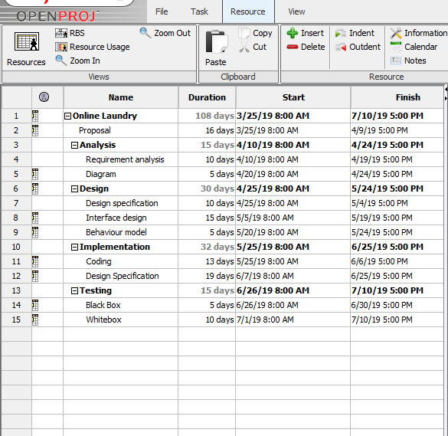

Figure 3: Scheduling 1

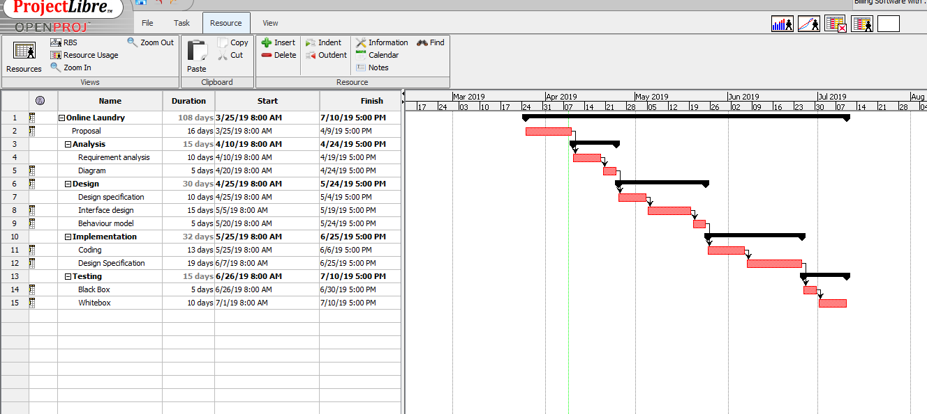

Figure 4: Scheduling 2

## Other project activities

### Risk management

No application is perfect in any case. There are always some defects. In this way, my framework is moreover not flawless but rather it is reliable. Be that as it may, there are a portion of the risks that might be powerless later on if not paid attention to. Thus, these risks must be sort out in the underlying stage for the better yield in future

The relation formula [*Impact = Likelihood * Consequence*] is used to calculate and evaluate risk factors.

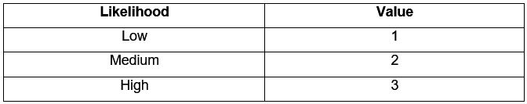

*Risk likelihood and values*

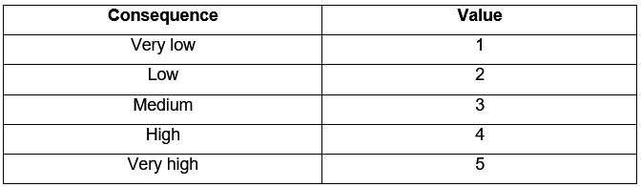

*Risk Consequence and Values*

|  |  |  |  |  |
| --- | --- | --- | --- | --- |
| Risks | Likelihood | Consequence | Impact | Action |
| Hardware failure | 3 | 4 | 12 | Data loss |
| System failure | 2 | 5 | 10 | No work should can be done |
| Bugs | 2 | 2 | 4 | May impact on the scheduling |
| Illness | 2 | 2 | 4 | Overtime duty can recover the lost time while being sick. |
| Natural disasters | 1 | 4 | 4 | Backup of data should be kept. |

### Configuration management

Configuration Management is the procedure that reviews the whole framework. It guarantees that any progressions made in one framework does not adversely influence any of other system. The application tracks and controls the adjustments in it.

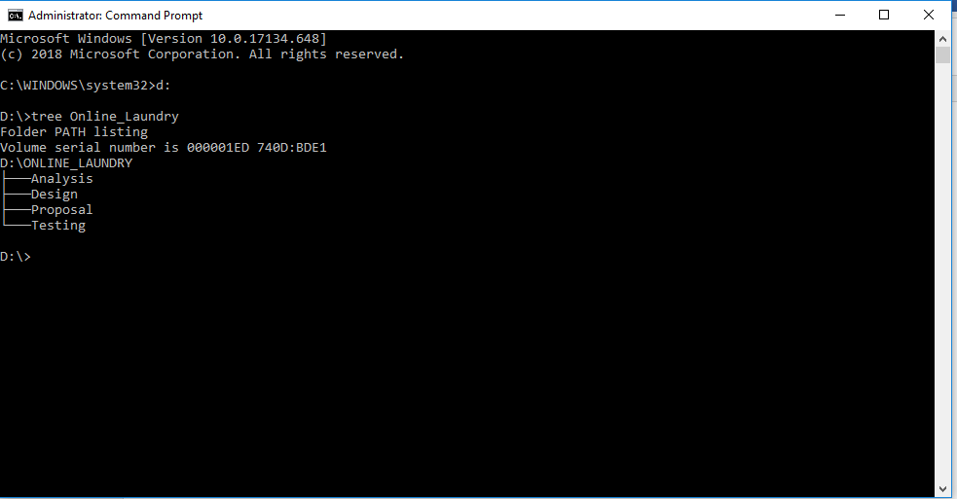

Figure 5: Configuration Management

# Conclusion

In this way, I am proposing Online laundry system connecting workers and client online for the project of Computing project. I have calculated all the time and schedules for completion of the project in time. It improves the laundry service to the customer in efficient and effective way along with small business are promoted, competing with other business in terms of technology sector. Time and scheduling will be followed strictly in order to complete the project in time.

# Bibliography

Anon., 2019. *Scope.* [Online]   
Available at: https://en.oxforddictionaries.com/definition/scope

EPA, n.d. *Development Method.* [Online]   
Available at: https://www.epa.gov/measurements-modeling/method-development